**New/Modified Connection or Diversion**

Example of Letter of Agency/Authority

(To be provided on the owner/occupier’s business letterhead if applicable)

Northern Powergrid

Connections Services

Alix House

Falcon Court

Preston Farm Industrial Estate

Stockton-on-Tees

TS18 3TX

To whom it may concern

RE: (Address of premises)

*We/I (insert name) of (insert correspondence address including email address) confirm that *we/I *are/am the legal and registered owner or occupier of the premises situated at (insert address of property), as highlighted red on the plan attached.

*We/I confirm that *we/I have appointed [insert name and company number of Company appointed]( or any consultant that they may authorise) as our/my agent(s) and they have continuing authority until dd/mm/yyy [duration of agreement] to act on our/my behalf in respect of a*new/diversion of the / modification to the existing (*delete as appropriate) electricity connection to *our/my premises.

Signed

Name (CAPITALS)

Date

(Insert Plan)

Sample plans (shown below) clearly showing the boundaries of the land or the premises referred to above.

*Delete as required

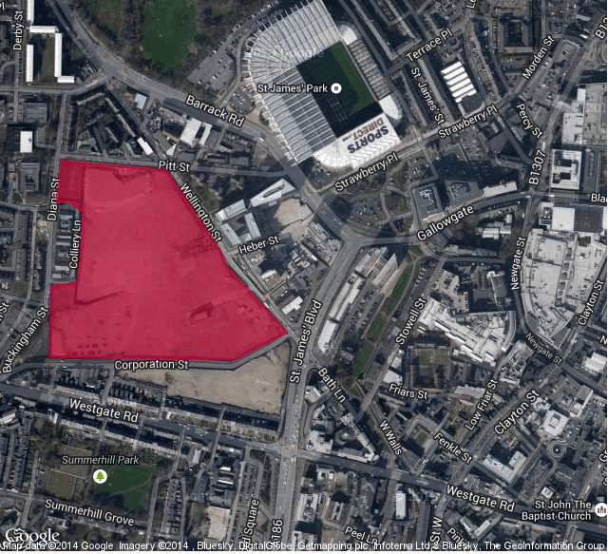 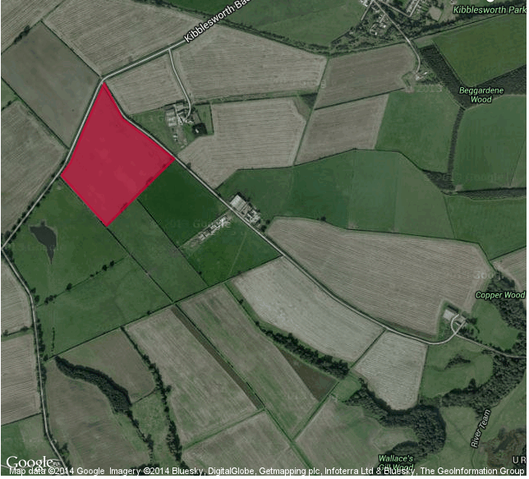

**Disconnection**

Example of Letter of Agency/Authority

(To be provided on the owner/occupier’s business letterhead if applicable)

Northern Powergrid

Connections Services

Alix House

Falcon Court

Preston Farm Industrial Estate

Stockton-on-Tees

TS18 3TX

To whom it may concern

RE: (Address of premises)

*We/I (insert name) of (insert correspondence address including email address) confirm that *we/I *are/am the legal and registered owner or occupier of the premises situated at (insert address of property), as highlighted red on the plan attached.

*We/I confirm that (*delete as appropriate) *[insert contact name, company name and company number of Company] is currently responsible for the premises and that *[insert contact name, company name and company number of Company] has continuing authority until dd/mm/yyy [duration of agreement] to act on our/my behalf in respect of the request to disconnect the premises from Northern Powergrid’s electricty distribution network.

Signed

Name (CAPITALS)

Date

(Insert Plan)

Sample plans (shown below) clearly showing the boundaries of the land or the premises referred to above.

*Delete as required

